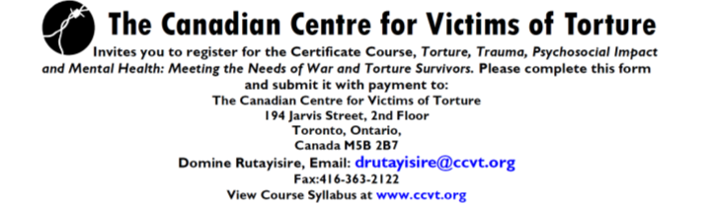
Register now: Virtual
Submit your form by September 30, 2021 to take advantage of early bird pricing!

Name: | Phone Number:
E-Mail: | Organization:

- Please note that by registering in this course, you agree to:
Register for the full course. I understand that registration for the complete 9-session course costs $400 (or Early Bird Price of $350).
The understanding that certificates will be awarded only to those participants in attendance for a minimum of 6 sessions.
1. Broad Aspects of Torture & Trauma (Dr. Wendell Block) October 13, 2021, 3:00-5:00pm
2. Trauma Stress & Resilience in Refugees (Dr. Clare Pain) November 17, 2021, 3:00-5:00pm
3. Mental Health Needs of LGBTQ+ Refugees (Ranjith Kulatilake) December 15, 2021, 3:00-5:00pm
4. A Cultural Psychiatry Approach to Refugee Women’s Mental Health (Dr. Lisa Andermann)
January 19, 2022, 3:00-5:00pm
5. Determinants of Refugee Mental Health (Dr. Branka Agic) TBC
6. Fostering Adaptation in Families, Children and Youth (Dr. Debra Stein) April 20, 2022, 3:00-5:00pm
7. Growing Older as a New Canadian (Dr. Irina Nica-Graham) May 18, 2022, 3:00-5:00pm
8. Recognizing the risks and signs of Addiction (Dr. Jonathan Bertram) June 16, 2022, 3:00-5:00pm
9. Self-Care: Vicarious Trauma (Teresa Dremetsikas, MD, Mexico & Mbalu Lumor)
June 29, 2022, 3:00-5:00pm

Please indicate your Method of Payment:
□ PayPal □ Master Card Card Number:
□ Cash Expiry date:
□ Cheque □ Visa

